**Research Title: POWERSYNC: OPTIMIZING ENERGY MONITORING THROUGH ARDUINO AND RASPBERRY PI SERVER BASED CONTROL SYSTEM**

**Authors:** Euder Wayne P. Dugay, Gabrielle C. Rivera, Lloyd Vince Angelo B. Tadeo, and Kenosis John B. Wajchina, RCpE (Adviser-Promoter)

**ABSTRACT**

This study focuses on developing an integrated energy monitoring and control system consisting of a Windows application and private website for the TTBDO. The Windows application is designed to monitor and control electrical loads within the facility, while the private website displays statistical reports of energy consumption over specific time periods. The project incorporates an IoT system using Arduino and Raspberry Pi, along with a scale model of the TTBDO for demonstration purposes. The primary objective is to create an integrated system that connects hardware components with software controls through LAN communication protocols, providing users real-time status updates about energy consumption via the website. The proposed solution aims to effectively monitor and control active loads on a miniature scale of the TTBDO while tracking and displaying energy consumption data.  
 **Keywords:** Windows App, Website, Energy Monitoring and Control, Raspberry Pi, Arduino

**INTRODUCTION**

Electricity is an essential but expensive resource. With the continued development of technology and infrastructure, energy demand is rapidly increasing. To ensure sustainable use, it is crucial to implement systems that monitor, control, and optimize energy consumption. One of the largest energy consumers in buildings is the HVAC system (Heating, Ventilation, and Air Conditioning), which can make up 40–70% of energy usage in commercial spaces. Effective monitoring helps optimize HVAC performance, lowering energy costs and improving operational efficiency (DEE, 2013).

Globally, it’s estimated that 66% of generated energy is wasted, primarily due to inefficient electrical devices, outdated insulation, and poorly optimized industrial systems. This waste significantly contributes to greenhouse gas emissions. Reducing this inefficiency can lead to substantial financial and environmental benefits (Ukpanah, 2024).

In the Philippines, rising electricity rates further emphasize the need for energy-saving measures. As of September 2024, Meralco increased its electricity rate by ₱0.1543 per kWh due to higher transmission costs (GMA News Online, 2024).

ISO 50001 is an international standard that provides a framework for developing energy policies, setting measurable goals, and improving energy performance through data-driven decisions. It promotes continuous improvement in energy efficiency and is applicable across industries (ISO, 2023).

A study by Akbar et al. (2023) showcased a web-based electricity monitoring system implemented in a university using a waterfall development approach. The system followed ISO 50001 principles and highlighted the benefits of real-time energy data for managing consumption and reducing costs.

**Arduino-Based Monitoring**

Recent studies emphasize the growing relevance of Arduino-based systems in energy monitoring and control applications. Degha et al. (2019) presented an Arduino-based energy monitoring system that offers real-time consumption data, enabling users to track usage habits, forecast energy needs, and increase awareness. The system's flexibility allows for future integration with artificial intelligence and multi-protocol communication, suggesting its potential evolution into a comprehensive building energy management solution.

Rosario et al. (2023) developed a Wi-Fi-enabled Arduino-based panel board, integrating Arduino Uno and Mega microcontrollers with the Blynk IoT platform. Their system demonstrated complete operational functionality with a zero error rate. Recommended enhancements include manual switches, I2C LCD screens, EEPROM memory, and features such as power bill calculations and voltage fluctuation prevention.

Similarly, Gomez et al. (2023) created a classroom energy control system leveraging IoT. Their application allows remote monitoring and management of various loads, including lighting and fans, by security personnel. The system used the PZEM-004T sensor for accurate current and voltage readings, validating the reliability of Arduino-IoT integration for real-time energy control.

Ramli et al. (2014) proposed a home energy management system using an Arduino microcontroller in conjunction with relays, PIR sensors, and temperature sensors. The system automatically adjusts appliance usage based on occupancy and environmental data, achieving estimated energy savings of at least 1.5%. The study highlights the system's scalability, making it applicable not only in residential settings but also in small-scale commercial environments.

**Smart Monitoring through IoT**

Recent studies underscore the utility of Internet of Things (IoT) technologies in advancing smart energy monitoring and control. Kassim et al. (2018) developed a smartphone application capable of tracking electricity usage across five campus buildings using smart meters. The system gathered data at 15-minute intervals and provided visual graphs through the Live Code platform, highlighting peak energy demand during midday and contrasting usage between working and non-working hours.

Ahmad et al. (2024) proposed a centralized IoT-based energy monitoring system tailored for legacy home appliances. By offering real-time energy consumption data, the system helps users identify inefficiencies in older devices. Its affordability and compatibility with non-smart appliances make it an effective solution for improving household energy efficiency and supporting broader sustainability efforts.

Park et al. (2019) introduced a wireless smart lighting system that leverages radio access modules and a mobility service for internet connectivity. The architecture enables high-speed data transfer and control using mobile devices operating within the ISM band. The study concluded that the system is both practical and cost-effective, and suggested that future implementations could benefit from Bluetooth mesh networks to enhance communication range and scalability.

Lalitha et al. (2023) presented an IoT-enabled energy monitoring and billing system that integrates an energy meter with a NodeMCU microcontroller. This system automatically collects consumption data and transmits it via Wi-Fi, providing users with real-time access to their energy usage and associated costs through the Blynk IoT platform. The solution reduces operational costs and improves billing transparency. Additional features include kilowatt-hour display via LCD, theft detection, and automated power cut-off, significantly enhancing security and functionality.

**Raspberry Pi Smart Monitoring**

Recent advancements in IoT have demonstrated the effectiveness of Raspberry Pi-based systems in improving energy monitoring, safety, and efficiency within residential environments. Poorvi et al. (2016) proposed a system that utilizes Bluetooth signal detection from users’ mobile devices and fitness trackers to determine occupancy. Upon detecting a user's absence, the system automatically deactivates unnecessary appliances such as lights and fans, thereby minimizing energy waste and reducing the risk of electrical fires. The design supports real-time monitoring and manual control, making it scalable and suitable for integration with broader IoT platforms.

Kumar et al. (2024) introduced a web-enabled residential energy monitoring system using components like Raspberry Pi Pico, PZEM004T energy meter, ESP8266 Wi-Fi module, and RFID for prepayment. The system calculates and displays electricity costs based on consumption in real-time, provides theft detection alerts, and wirelessly transmits data to a centralized web interface. It enhances energy transparency and supports sustainable practices by automating billing and consumption tracking.

To address limitations in traditional metering systems, Devi et al. (2019) proposed an Automatic Meter Reading (AMR) system based on the Raspberry Pi. The AMR system utilizes voltage and current sensors to detect fluctuations and automates the control of household appliances accordingly. It communicates energy usage and billing details online, provides tamper detection, and eliminates the need for manual inspections—significantly improving billing accuracy and operational efficiency.

Purwania et al. (2020) emphasized the environmental potential of IoT-based energy monitoring systems, noting their role in mitigating global warming through real-time tracking and efficient power use. IoT solutions in smart buildings and homes often rely on cost-effective microcontrollers and cloud infrastructure to deliver scalable energy management capabilities.

Similarly, Saranraj et al. (2023) developed a web-based monitoring system using Raspberry Pi Pico and associated hardware to enable real-time electricity tracking. The system displays usage data and calculated costs on an LCD, includes theft detection via current coils, and supports RFID-based user payment tracking. The data is transmitted via a web server or mobile app, offering a practical, low-cost solution for residential energy management.

**NODE RED and MQTT Prototyping**

Node-RED and MQTT have emerged as vital technologies in the development of Internet of Things (IoT) systems due to their flexibility, scalability, and ease of integration. Node-RED, originally developed by IBM Emerging Technology Services and now maintained by the OpenJS Foundation, is a flow-based development tool that features a browser-based visual editor for creating automation workflows. It allows users to construct JavaScript-based functions and reuse code through its built-in library, significantly simplifying the development of complex IoT applications (OpenJS Foundation & Contributors, n.d.).

MQTT (Message Queuing Telemetry Transport) is a lightweight, publish-subscribe messaging protocol designed for efficient communication in low-bandwidth and high-latency environments. Initially developed for telemetry in oil pipelines, MQTT is now widely adopted across industries such as smart energy, logistics, and automotive. It provides a reliable communication layer for M2M and IoT applications, enabling real-time monitoring and control. A case study by Cirrus Link Solutions (n.d.) highlights how a multinational energy firm integrated MQTT with SCADA systems to modernize its operational technology infrastructure, improving data collection and system monitoring (Steve Cope, 2021; Cirrus Link Solutions, n.d.).

Ferencz et al. demonstrated the advantages of combining Node-RED and MQTT in Industrial IoT (IIoT) environments. These technologies allow for rapid prototyping, efficient data visualization, and streamlined process logic, offering significant improvements over traditional systems. Their integration supports predictive maintenance and enhanced extensibility, ultimately contributing to optimized industrial performance.

Onwuegbuzie et al. (2024) further explored the synergy between Node-RED and advanced IoT analytics. Their findings emphasize the ability of Node-RED to manage large-scale IoT data with minimal coding, reducing development time and enabling intuitive visual representations of complex datasets. This integration showcases a promising path for future research in scalable and efficient IoT data processing systems.

Thomas et al. (2024) presented a low-cost home automation system using Node-RED and MQTT in conjunction with Wireless Sensor Network (WSN) technology. Their implementation supports remote control of household devices and provides automated notifications via email, reinforcing the practicality of these tools in smart home applications and reinforcing their adaptability in both industrial and residential contexts.

**Conceptual Framework**

**Figure 1**

*Conceptual Framework*

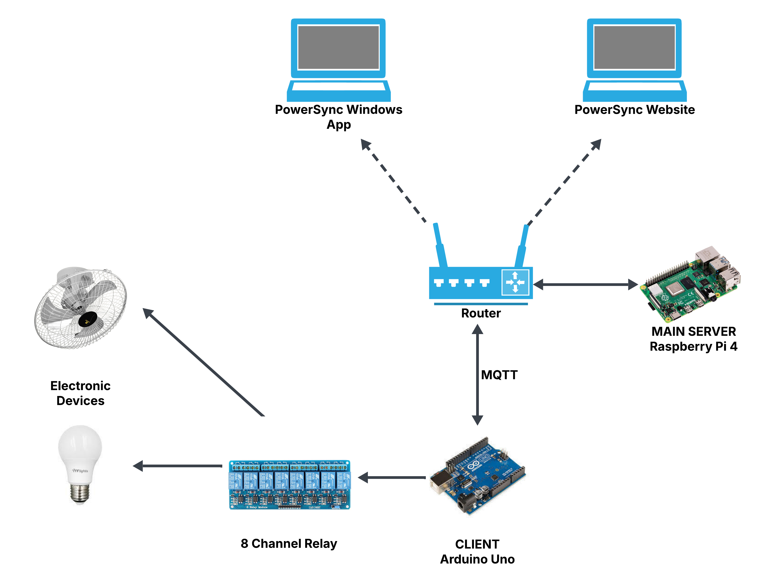

Researchers are developing software to process MQTT messages sent via Arduino ethernet shield and Raspberry Pi as a broker connection. The Arduino Uno controls electrical loads in a building, while Raspberry Pi handles web hosting and database management. The LAMP stack (Linux, Apache MySQL, PHP) is used for the software, with Node Red as the bridge between hardware and software. The frontend website uses HTML, JavaScript, and CSS, while the Windows app displays energy consumption and statistics. Data is relayed in Node Red via publish and subscribe protocol and saved on a micro-SD card for future access.

Arduino controllers and relay boards control electrical loads across buildings, scalability allows for remote management without extensive reconfiguration, and new buildings can be added to the Windows application control panel.

**Figure 2**

*Conceptual Framework for Scalability*

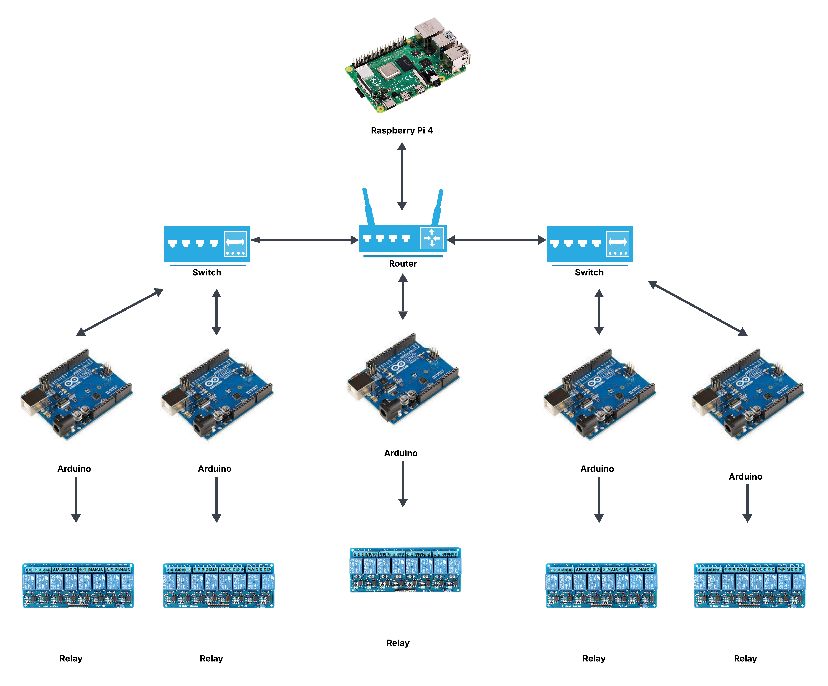

**Statement of the Problem**

This study seeks to address unmonitored energy consumption by implementing an Arduino-based monitoring and control system, accessible via software developed by researchers. To achieve this objective, the following questions were posed:

1. How can an Arduino and a Raspberry-Pi server-based monitoring and control system be effectively integrated with software?
2. Is it feasible to establish a connection between software controls, Arduino, Raspberry-Pi and the associated hardware?
3. How will the system communicate information about the status of the electrical components to the user?

**Scope**

The system uses Raspberry Pi and Arduino as core platforms and an 8-channel relay board as panelboard controllers for seamless control of electrical components. A Windows app allows university administration and guards to monitor loads and a private website for energy consumption monitoring.

**Delimitations**

The prototype focuses on developing a Windows app and a private website using Raspberry Pi for monitoring and controlling electrical loads and displaying weekly consumption summary within TTBDO building.

**METHODOLOGY**

**Research Design**

This study will implement software prototyping methodology using the Systems Development Life Cycle (SLDC), specifically the AGILE Methodology, as the research design. AGILE was selected for its formalized yet flexible approach and emphasis on collaboration, making it particularly appropriate for the project’s needs. Since this study represents a collaboration between Computer Engineering and Electronics and Communication Engineering teams, the AGILE methodology provides a logical framework that prioritizes integrity and functionality. The researchers will follow AGILE’s distinct phases or stages to systematically develop and assemble the software system.

**Figure 3**

*AGILE Development*

**Research Locale**

The research will be conducted at Saint Mary's University in Bayombong, Nueva Vizcaya, with specific implementation on the TTBDO of the School of Engineering, Architecture and Information Technology (SEAIT). The prototype is designed to monitor electrical loads and provide control through a Windows application, while also featuring a website that displays statistical graphs of power, voltage, current, and electrical consumption.

**Data Gathering**

For data collection, the researchers will conduct online surveys to evaluate the usability and user-friendliness of both the Windows application and website. The primary data sources will be sensor readings from the ECE group's Wattcher device, which uses Arduino to monitor energy consumption, and server logs. The Wattcher connects to a router via LAN, transmitting data to a Raspberry Pi that stores information in a MySQL database. System performance will be assessed through transmission accuracy logs and response time measurements, while the online surveys will provide qualitative feedback on usability and functionality to guide final system adjustments.

**Software Description**

The energy monitoring system is designed with dual capabilities: controlling electrical loads in the TTBDO facility and visualizing power consumption data collected from sensors. Key features include graphical data displays and historical analysis capabilities that allow users to review past energy consumption patterns. The system consists of a web-based interface for monitoring and a Windows application for control, both incorporating user management at different access levels. The architecture follows a client-server model, with PHP handling server-side logic and database interactions using MySQL within a LAMP web server setup. The front-end dashboard utilizes JavaScript, HTML, and CSS, with Charts JS providing web visualization tools while Scott Plot handles visualizations for the desktop application built in C#. The system leverages Node-Red's built-in functions for scalability, while the Raspberry Pi implements encryption to secure data transmission between clients and sensors. This infrastructure is designed to be scalable, allowing for potential expansion to monitor and control multiple buildings.

**System Architecture**

**Figure 4**

*System Architecture*

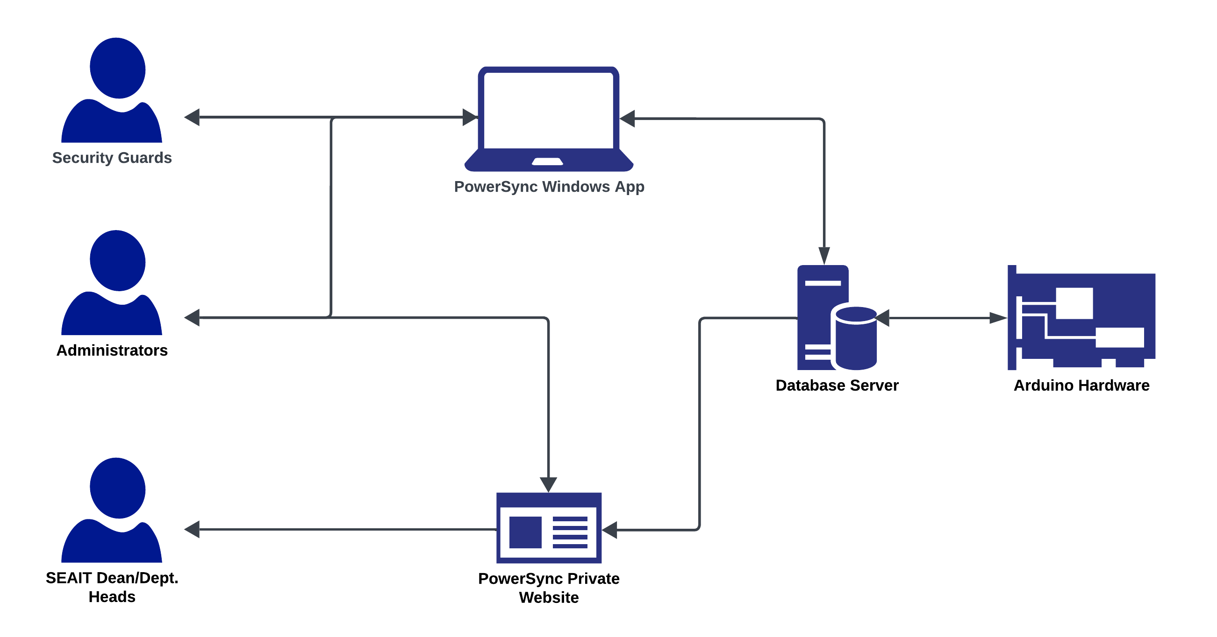

This system architecture outlines the workflow for different user types interacting with the energy monitoring and control system. Administrators and Security Guards can actively control energy consumption at the TTBDO (Technology Transfer and Business Development Office) through the Windows application. The SEAIT Dean and Department Heads, along with administrators, can access the PowerSync private website to view energy consumption data. The entire system is designed exclusively for use within Saint Mary's University, specifically for the TTBDO facility. The technical infrastructure is divided between two platforms: the PowerSync Windows application operates over the Local Area Network (LAN), while the private website is hosted on a Raspberry Pi system.

**PowerSync Website**

**Figure 5**

*Website Flowchart*

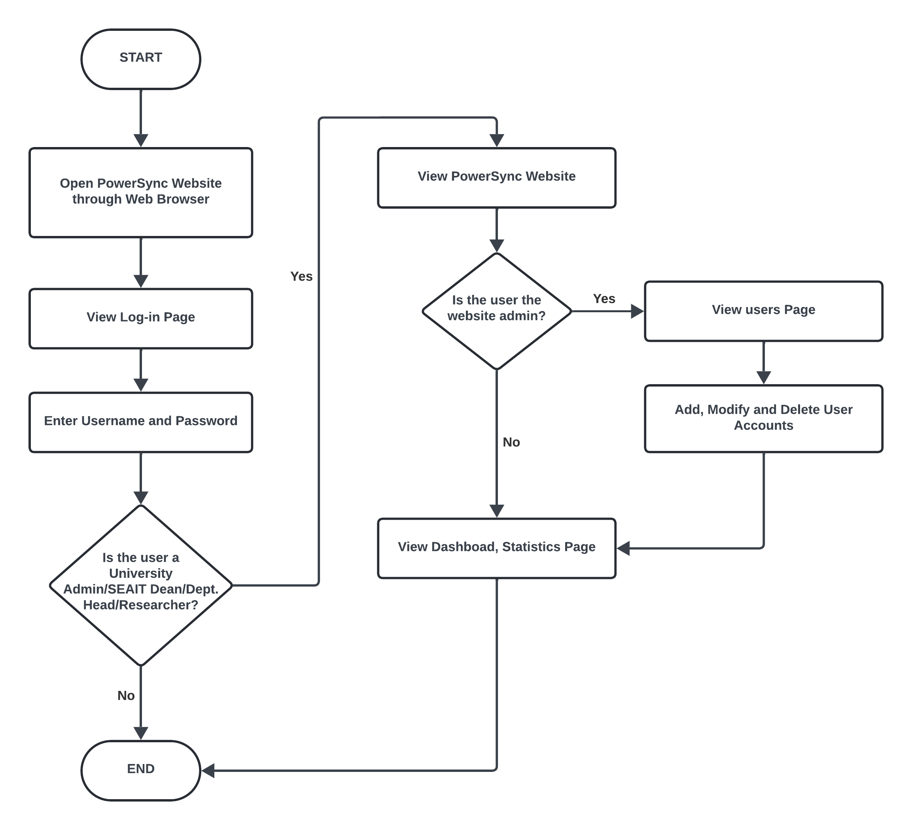

The PowerSync Website interface is designed for use by university administration, the SEAIT dean, and department heads. System administrators (the researchers) are responsible for creating user profiles and providing login credentials to these stakeholders. To access the website, users must open a web browser, navigate to the PowerSync Website login interface, and enter their unique account name and password. After successful authentication, they are redirected to the main website interface. Both administrators and stakeholders can view the Dashboard and Statistics pages, which display energy consumption data. However, access to the user management page is restricted exclusively to system administrators to maintain security and ensure only authorized personnel can access the website.

**PowerSync Windows App**

**Figure 6**

*Windows App Flowchart*

The PowerSync Windows App is accessible to both university administrators and Security Guards, with administrators using their existing accounts and Security Guards provided with separate login credentials. Once logged in, users are directed to the Dashboard, which displays key statistical data such as current active electrical loads, weekly consumption, and an hourly consumption graph. Additionally, users can access the Control Interface, which presents a visual layout of the building, highlighting rooms with active electrical loads and allowing for remote control of those components. Access is restricted to registered users, and unregistered individuals cannot bypass the login screen on either the app or the website.

**Treatment of Data**

The study will use qualitative methods, particularly online surveys, to assess the user-friendliness of PowerSync’s interface. Due to time constraints, Python-generated test data will be used in place of actual data from Wattcher’s sensors. This simulated data will be sent to a Raspberry Pi server for energy tracking and stored in a MySQL database. User feedback on both the private website and Windows application interfaces will guide the qualitative analysis, with survey results informing UI improvements. The website dashboard will present data visually through graphs, offering stakeholders insights into energy consumption trends.

**Ethical Consideration**

The study will be approved by Saint Mary's University Research Ethics Board (UREB), who will be contacted via email or phone. The study adheres to ethical considerations for responsible research practices.

***Disclosure of Conflict of Interest****.* There are no conflicts in conducting this study.

***Confidentiality and Data Protection***. The privacy and confidentiality of data collected through online surveys and the energy monitoring system will be prioritized, with secure storage on the Raspberry Pi server and encryption measures in place to protect sensitive information. Additionally, the study emphasizes transparency in the use of collected data, ensuring it is only employed for the intended purpose of optimizing energy consumption within the designated area. Data gathered would be used until the second semester of the school year 2024-2025 after which it would be then disposed of to prevent data leakage.

***Conflict of Interest***. There will not be any personal gain from the researchers from the study that could compromise the objectives of the study.

***Terms of reference***. The study will be submitted and owned by Saint Mary’s University, but the researchers shall continue to be its authors.

***Dissemination Plan****.* The researchers are targeting to present the results of the study, in collaboration with the ECE research study of Wattcher: An Electrical Energy Monitoring System with LAN Connectivity, to offer as a solution for the institute’s energy consumption. It will also be presented to different research fora as references for future development and studies.

**RESULTS AND DISCUSSION**

This chapter contains the results and insights gained during the development of the Windows App and website as well as the survey results. It also describes the prototype development of the Windows App and website. The prototype also consists of a miniature scale model of the TTBDO mounted on a plywood board.

**Hardware Development**

**Creating the miniature model of the TTBDO**

1. Connect dedicated pins to the relay module to the Arduino board.
2. Connect the LED Bulbs to the relay board (Refer to figure 7).
3. Place the hardware components on a tabletop scale model (Refer to figure 8).

**Figure 7**

*LED connection to relay board*

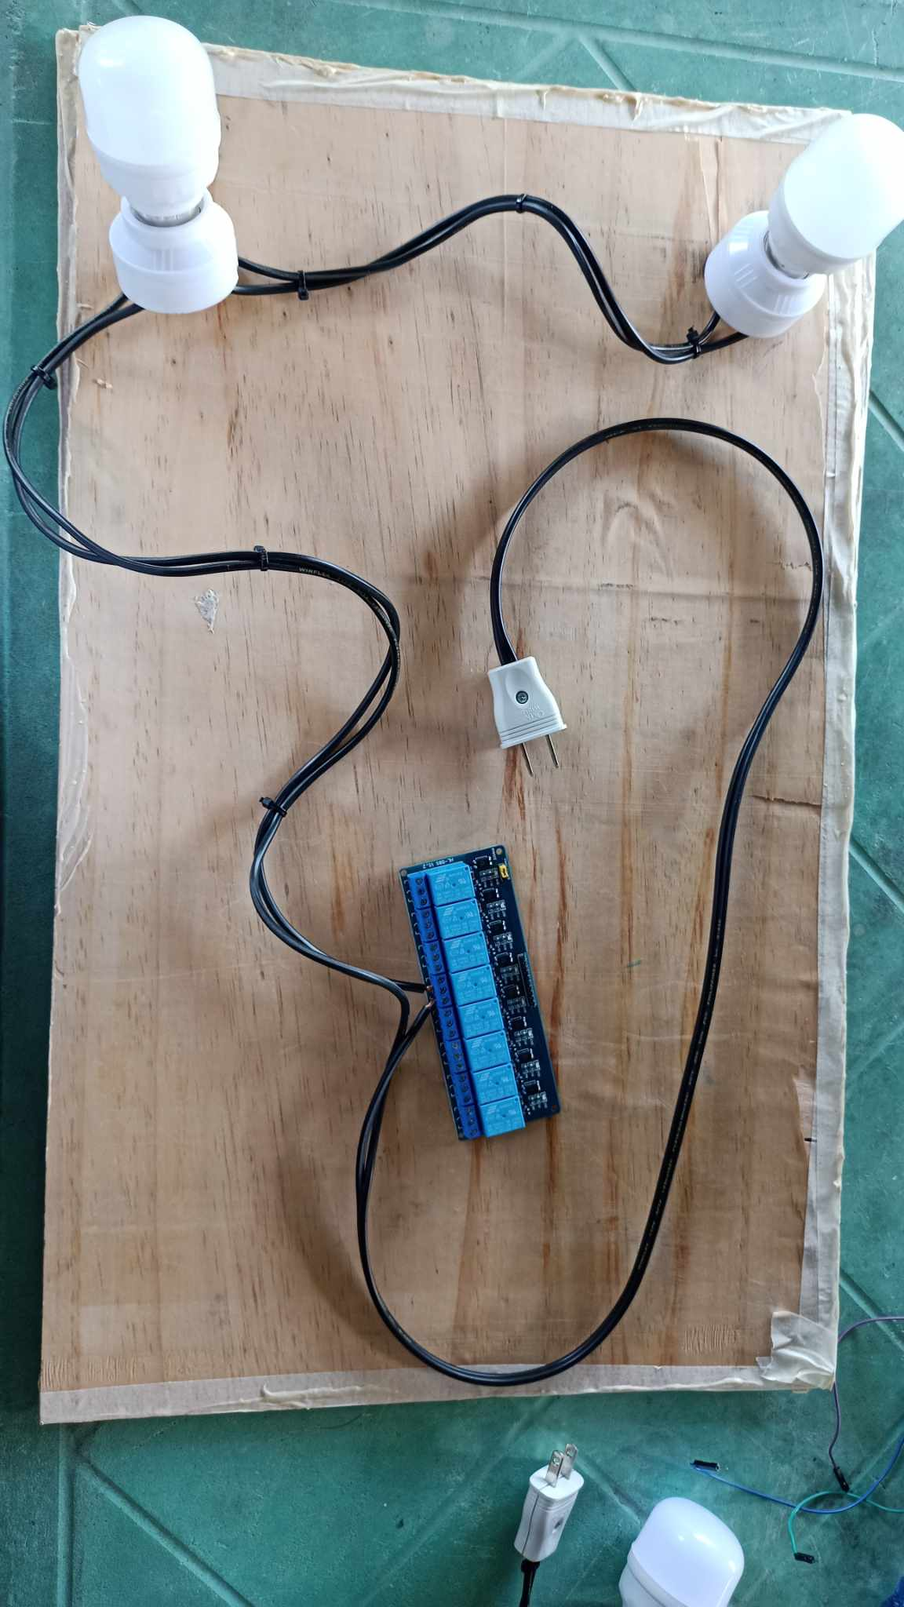

**Figure 8**

*Hardware components to scale model*

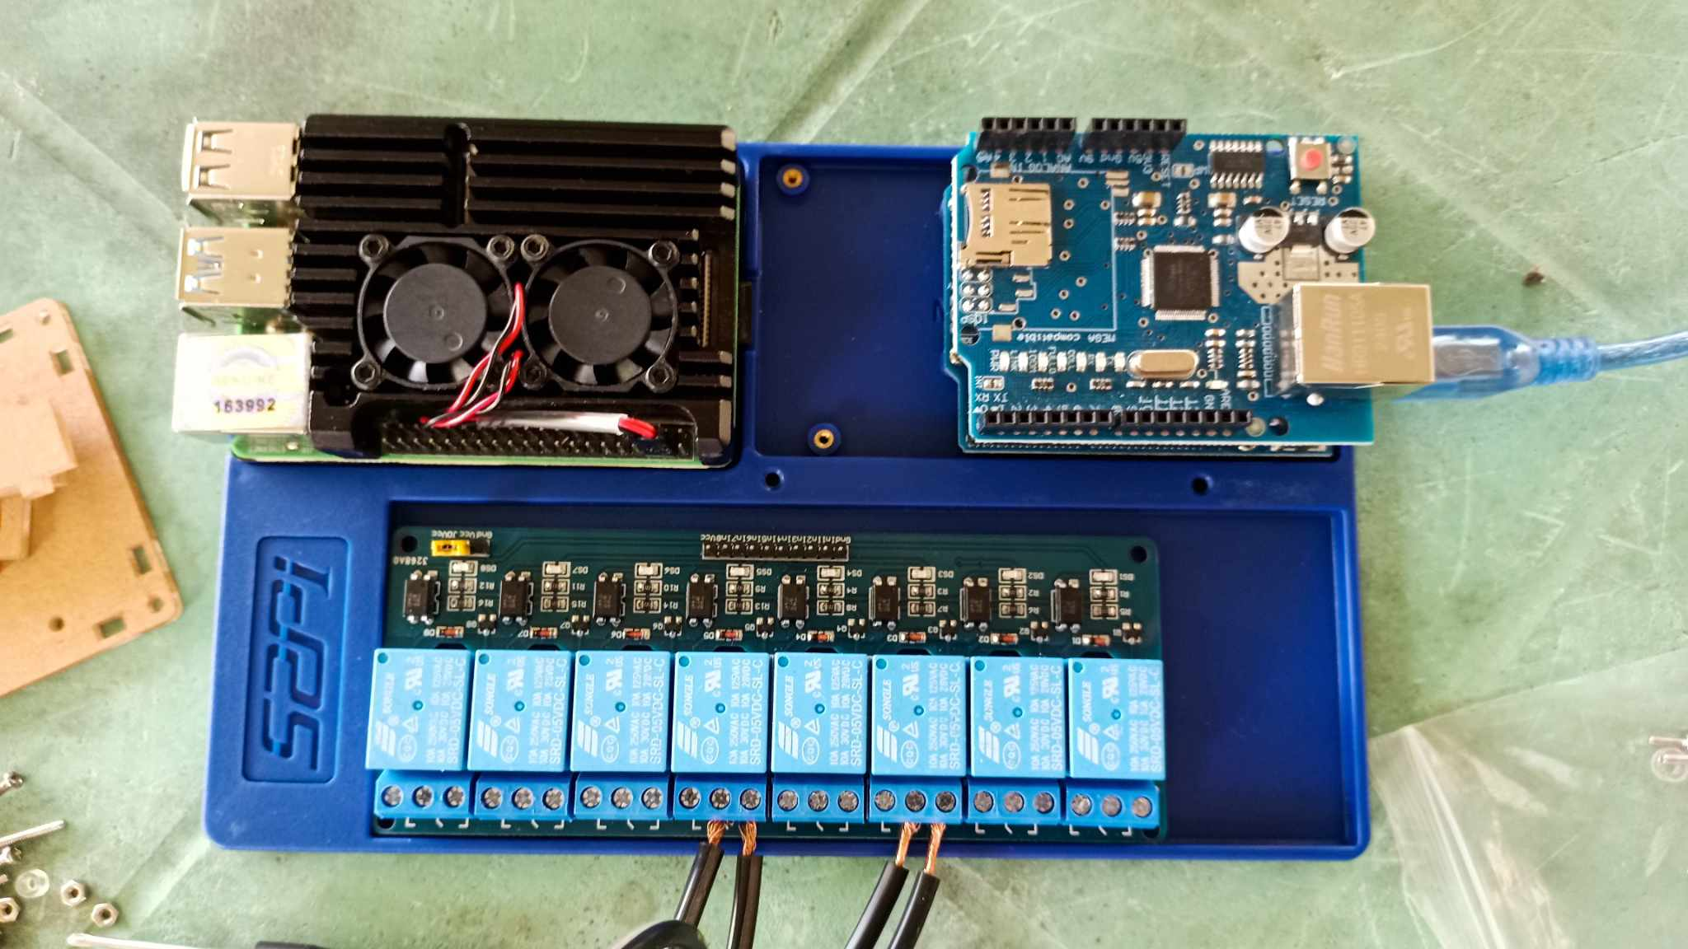

**Establing the Raspberry Pi 4 as the server**

1. Use Node-RED script to establish a connection for sensor to database connection (Refer to Figure 9).
2. Determine if the router can detect the Raspberry Pi (Refer to Figure 10).
3. Input the Linux commands through the Raspberry Pi terminal, this is where most of the applications and API’s to be hosted on the Raspberry Pi are installed (Refer to Figure 11).
4. Create the database using phpMyAdmin.

**Figure 10**

*Detecting the Raspberry Pi within the router*

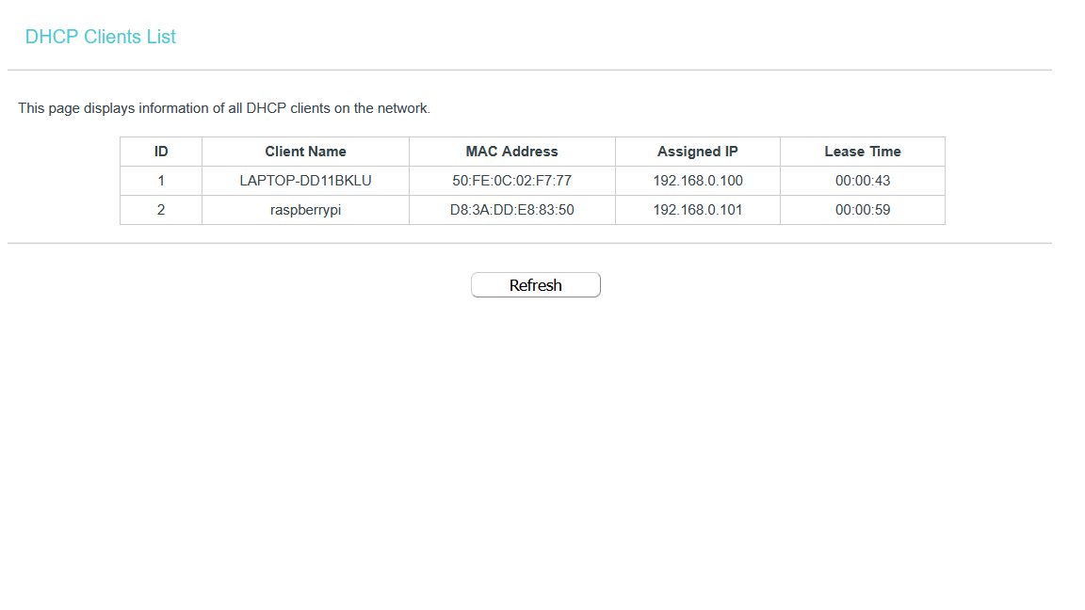

**Figure 9**

*Deployed Node- RED Flow Diagram*

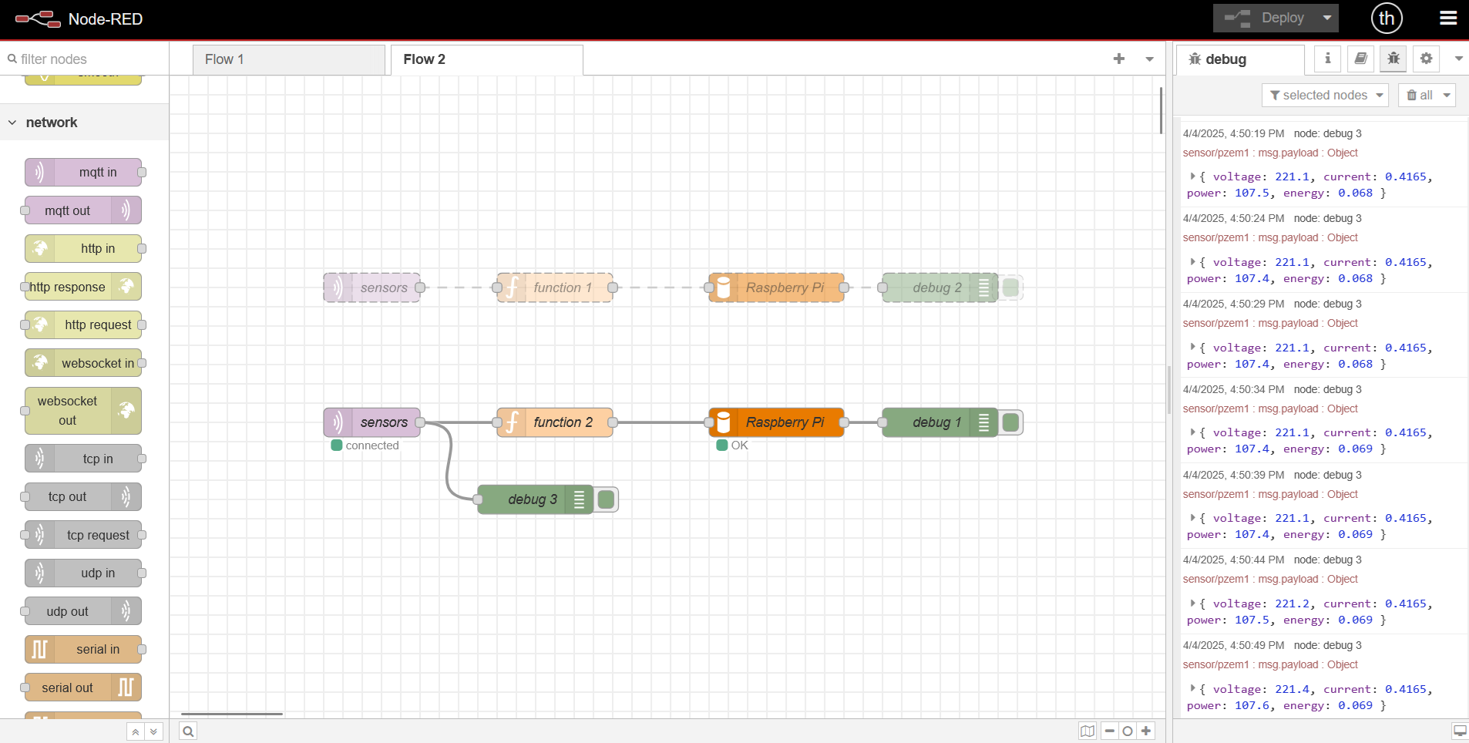

**Figure 11**

*Raspberry Pi Terminal*

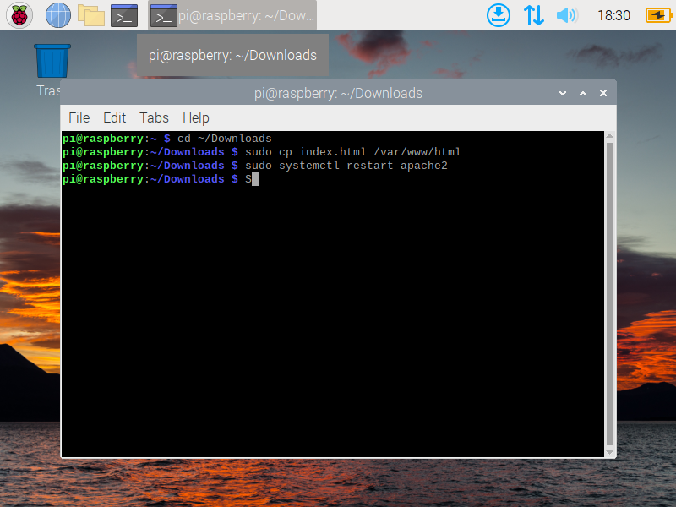

**System Functionalities**

**PowerSync Windows App (For monitoring and control)**

**Figure 12**

*Login Page*

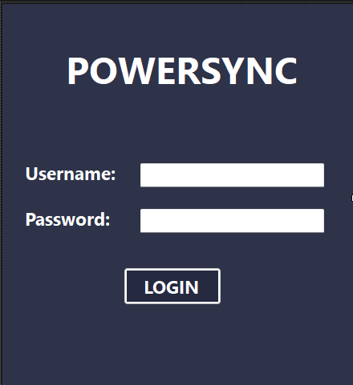

The login page for the Windows app platform requires University Administration and Security Guards to enter their provided username and password, ensuring only authorized users can access the system.

**Figure 13**

*Dashboard*

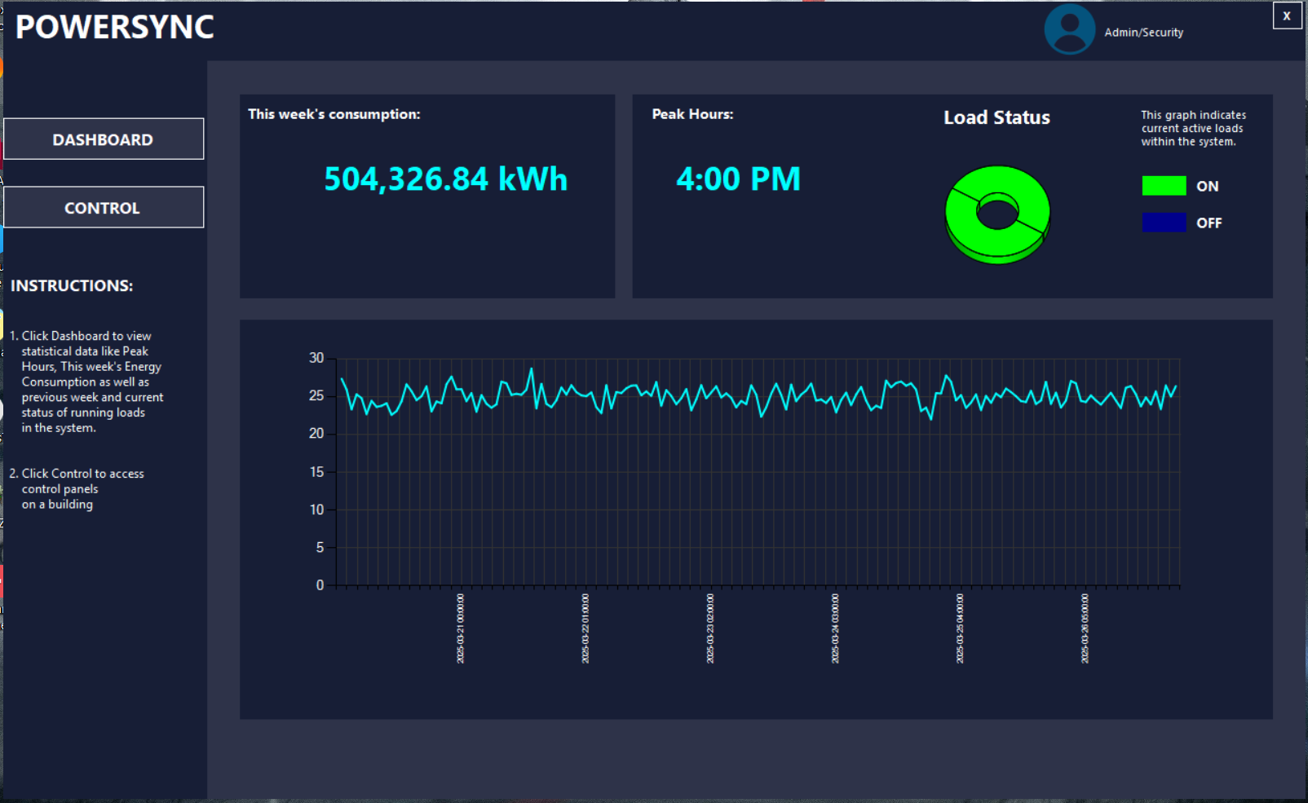

The dashboard shows power consumption, peak hours, and active loads, with statistical graphs. Users can access the control page to monitor and control electrical loads within the TTBDO by clicking on the Control button.

The study's main site focus is the TTBDO, which users can view and control through two panels: Panel 1 for Office and Makerlab, and Panel 2 for Laboratory. Users can turn on and off electrical loads by clicking on the green and red buttons.

**Figure 14**

*Control Page*

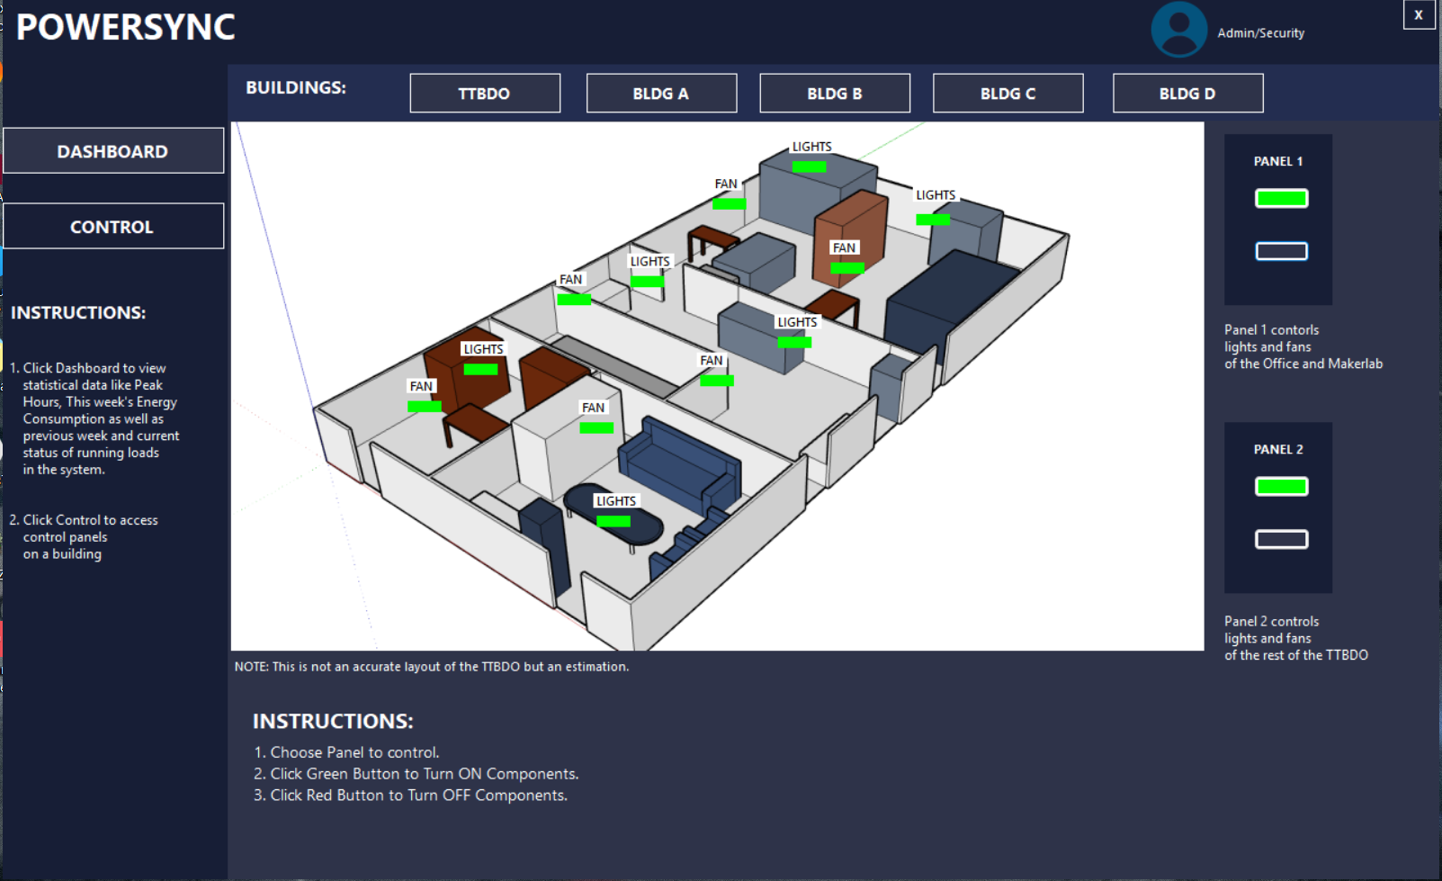

**Figure 15**

*Bldg. A, B, C, D Control Panel*

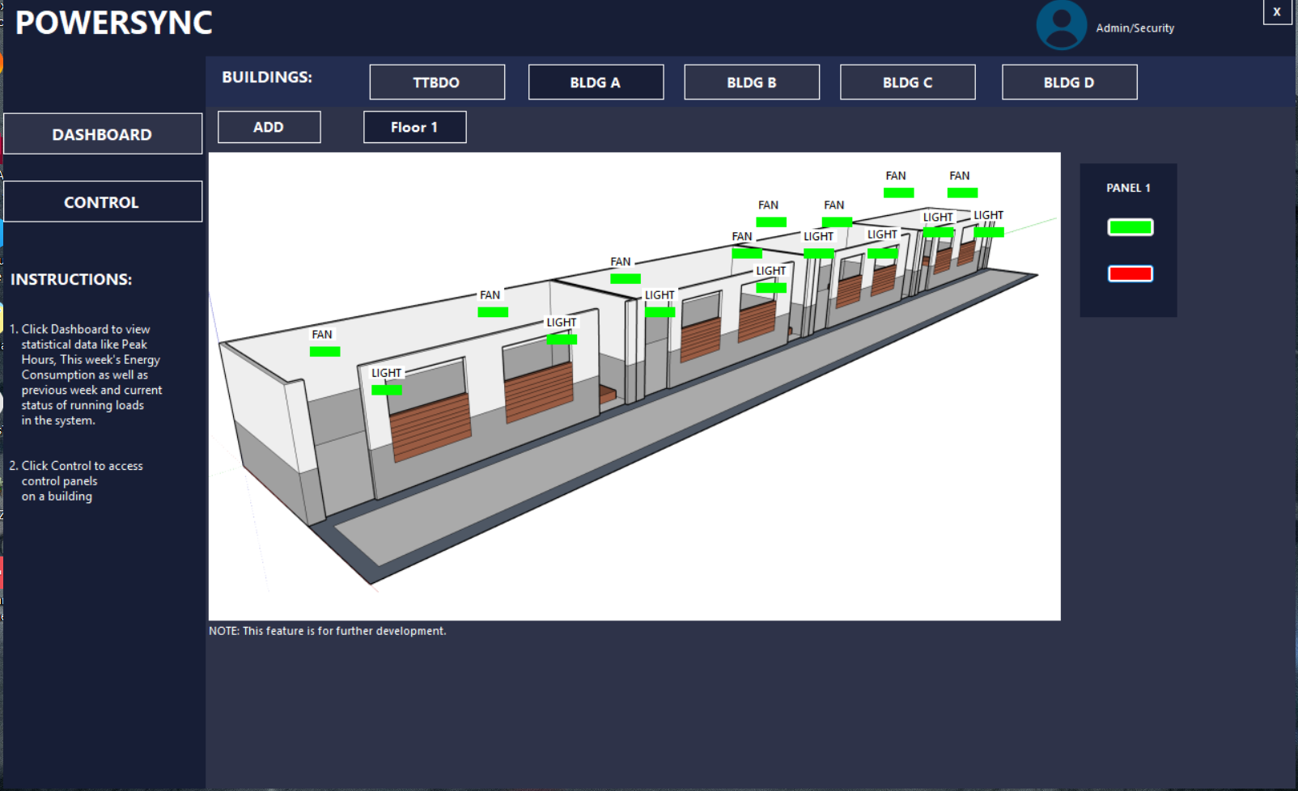

Control panels allow future system scalability and building floor addition. Users can control floors by clicking green and red buttons to turn "ON" and "OFF" loads.

**PowerSync Website (Statistics)**

**Figure 16**

*Login Page*

The website login page requires University Administration, SEAIT Dean, and Department Heads to enter their username and password, with an "Invalid username or password" message indicating incorrect input, ensuring only authorized users can access the system.

**Figure 17**

*Dashboard for the Admin (Researchers)*

The website's dashboard displays average current consumption, peak time, system status, and a line graph of current, current used, and peak hours within the last 24 hours and 7 days. It also shows the admin user is logged in, has statistics, users, and a logout button.

**Figure 18**

*Dashboard for Users (University Administration, SEAIT Dean and Department Heads)*

The main dashboard for the users guards the same as the main dashboard for the admins but with the exclusion of the users’ page.

**Figure 19**

*Statistics Page*

The page provides detailed statistics on power consumption, including average, minimum, maximum, and standard deviation values, visual bar graphs, and pie charts for current consumption by time of day, accessible to both users and admins.

**Figure 20**

*Users Page (Only for Admins)*

The users page can only be accessed and be viewed by the admin. This allows the admin to manage all the user accounts. The admins are able to add new users, edit or delete current users.

**Interface User-Friendliness Evaluation**

The online usability assessment gathered feedback from 25 participants who evaluated our interfaces based on user-friendliness criteria. The structured evaluation provided valuable insights into the effectiveness of our current design approach and highlighted specific areas of strength and opportunity for enhancement.

**Figure 21**

*Online Survey Results (Windows App)*

Analysis of the UI satisfaction survey reveals compelling results: 68% of users rated the system interface as "Excellent," while 22.67% considered it "Commendable." Only 8% of respondents assessed the UI as merely "Competent," with a minimal 1.3% finding it "Challenging."

**Figure 22**

*Online Survey Results (Website)*

Analysis of the user experience data reveals exceptional satisfaction levels, with 69% of respondents awarding the system interface the highest rating of "Excellent." An additional 22% classified the UI as "Commendable," while the remaining 9% evaluated it as "Competent."

**CONCLUSIONS AND RECOMMENDATIONS**

**Conclusion**

Both the website and the Windows app show complete functionality based on the prototype's testing. The effectiveness of the study's goals is demonstrated by the evidence that follows.

1. The project successfully links Arduino and Raspberry-Pi communication to the hardware components through a LAN connection utilizing Node-RED and MQTT protocol.
2. The researchers successfully developed a fully operational and scalable monitoring and control system for electrical loads.
3. The system was able to establish a connection with Wattcher but due to time constraints, the researchers still opted to use generated data as data readings from Wattcher is not yet available.
4. Data from online surveys indicates remarkable user approval, with more than 90% of respondents evaluating the interface as exceeding typical standards, and notably, no participants provided negative feedback.

**Recommendations**

The following recommendations are for future researchers and studies aiming to enhance the current prototype. These suggestions are also directed towards the beneficiaries of this study.

1. Enhance UI design and functionality of the Windows App and Local Website.
2. Make more use of the Raspberry Pi instead of only utilizing it as a server.
3. Use ESP32 or ESP8266 rather than Arduino UNO and Wiznet 5100 since it is more cost effective and does twice the same job with just one component rather than two.
4. Improve scalability of the project by giving access to monitor and control more buildings.
5. Implement a timer indicator that displays the remaining time until electrical loads will be remotely turned off in a room.

**REFERENCES**

Ahmad, S. S., Almasalha, F., Qutqut, M. H., & Hijjawi, M. (2024). Centralized smart energy monitoring system for legacy home appliances. Energy Informatics, 7(1).

Akbar, F., Pujani, V., & Nazir, R. (2023). Design of real time electricity consumption monitoring system using campus web. *TEM Journal*, 840–849.

Cirrus Link Solutions. (n.d.). *Energy Company Maximizing MQTT for Control and Efficient Image Data Transfer*. Cirrus Link. Retrieved March 30, 2025

Degha Houssem Eddine, Laallam, F. Z., Maroua Seggar, & Ayachi Omar Chaima. (2019). *Implementation of an energy monitoring system based on Arduino*. Artificial Intelligence and Its Applications.

Department of the Environment and Energy (DEE). (2013, September 1). *HVAC factsheet—Energy breakdown.*

Devi, P. B., Mohammed Abdul Ayub, M., Robert Raja, A., Shri Vishnu Kumar, V., Vishnu, V., & SSM Institute of Engineering and Technology. (2019). *Automatic Energy Meter Reading using Raspberry PI and IOT [Journal-article].* SSRG International Journal of Electronics and Communication Engineering, 2019(Special Issue ICRTCRET), 19.

Ferencz, K., Domokos, J., Sapientia Hungarian University of Transilvania, Romania, Targu-Mures, & Sapientia Hungarian University of Transylvania, Faculty of Technical and Human. (2020). Using Node-RED platform in an industrial environment. In *XXXV. Jubileumi Kandó Konferencia*.

Gomez, P., Ignacio, J., Piscoso, N., & Toledo, K. (2023). *Control and Monitor of Electrical Loads in a Classroom using IoT Technology*. Saint Mary’s University, Bayombong, Nueva Vizcaya.

IBM. (2024). *What is Energy Management? | IBM*.

*IoT with Raspberry Pi: The Perfect Match for Smart Solutions*. (2023, October 26).

*ISO - ISO 50001 — Energy management*. (2023, May 30). ISO. https://www.iso.org/iso-50001-energy-management.html

Kassim, M., Rahman, M. A., Yahya, C. K. H. C. K., & Idris, A. (2018). *Mobile application for electric power monitoring on energy consumptions at a campus university.* Indonesian Journal of Electrical Engineering and Computer Science, 11(2), 637.

Kumar, B. J., Prasad, G. D., Sowjanya, J., & Kumar, R. (2024). *Design of raspberry pi web-based energy monitoring system for residential electricity consumption*. *In IRACST – International Journal of Computer Networks and Wireless Communications (IJCNWC).*

Lalitha, K. V., VasuBabu, K., Karthik Kumar, T., Srilakshmi, N., & SivaTeja, K. (2023). *Automatic energy meters monitoring in buildings and apartments using IoT technology*. Journal of Emerging Technologies and Innovative Research (JETIR), 10(3).

News, T. C., GMA Integrated. (2024, September 11). *Meralco hikes electricity rate anew in September 2024*. GMA News Online.

Nigam, S., Sugandh, U., & Khari, M. (2022). *The integration of blockchain and IoT edge devices for smart agriculture: Challenges and use cases. In P. Raj, K. Saini, & C. Surianarayanan* (Eds.), Advances in Computers (Vol. 127, pp. 507–537). Elsevier.

Onwuegbuzie, I. U., Olowojebutu, A. O., Kehinde, K. K., & The Federal Polytechnic, Ado-Ekiti. (2024). Node-RED and IoT Analytics: A Real-Time Data Processing and Visualization Platform. *Tech-Sphere Journal of Pure and Applied Sciences (TSJPAS)*, 1–12. https://doi.org/10.5281/zenodo.13856860

Park, H., & Kim, S. (2019). A Study on Monitoring and Control Architecture for Smart Lighting System in IoT Environment. Asia-pacific Journal of Convergent Research Interchange, 5(3).

Poorvi, J., & Sunil, M. (2016, November). *Raspberry Pi based Energy Management System*.

Purwania, I. B. G., Kumara, I. N. S., Sudarma, M. (2020). *Application of IoT-Based System for Monitoring Energy Consumption*. In International Journal of Engineeringand Emerging Technology: Vol. Vol.5 (Issue No.2, p. 81).

Ramli, K. N., Joret, A., & Saad, N. H. (2014). *Development of home energy management system using Arduino*. Faculty of Electrical and Electronic Engineering.

Ravikiran, A S. (2024, July 23). *What Is Raspberry Pi?*

Rosario, J., Bucahan, P., Pulinnek, A., & Andres, M. (2023). *Arduino-Based Control and Monitoring of Electrical Panel Board*. Saint Mary’s University, Bayombong, Nueva Vizcaya.

Saranraj, B., Janarthanan, R., Selvakumar, K., Sridhar, D., & Electronics and Communication Engineering Department, PACET. (2023). *Web-Based Energy Monitoring System and Tariff Calculation for Residential Electricity Consumption*. In *Journal of Survey in Fisheries Sciences* (Vol. 10, Issue 4S, pp. 1562–1566).

Siemens industry, Inc. (2016). Basics of Panelboards.

Steve Cope. (2021, February 12). *MQTT - The Standard for IoT Messaging*. Http://Www.Steves-Internet-Guide.Com/.

Thomas, L., Mv, M. K., Sl, S. D., & Bs, P. (2024. *Towards Comprehensive Home Automation: Leveraging the IoT, Node-RED, and Wireless Sensor Networks for Enhanced Control and Connectivity*. https://doi.org/10.3390/engproc2023059173

Ukpanah, I. (2024, July 10)*. Energy Waste: A Deep Dive into Environmental Consequences. GreenMatch.Co.Uk.* https://www.greenmatch.co.uk/blog/energy-waste

*What Is Raspberry Pi? Here’s The Best Guide to Get Started | Simplilearn*. (n.d.). Simplilearn.Com. Retrieved October 27, 2024, from https://www.simplilearn.com/tutorials/programming-tutorial/what-is-raspberrypi